Creating new app using NPM library and thirdweb source

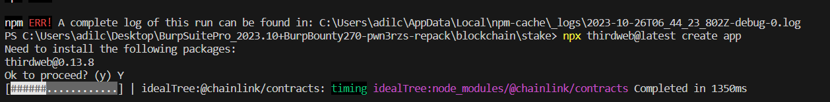

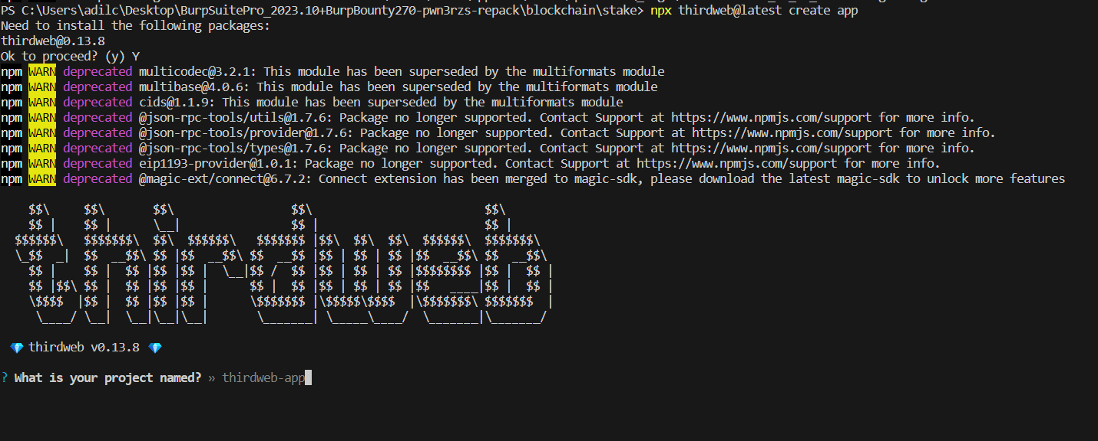

Install chakra-ui for creating the frontend part for the dApp

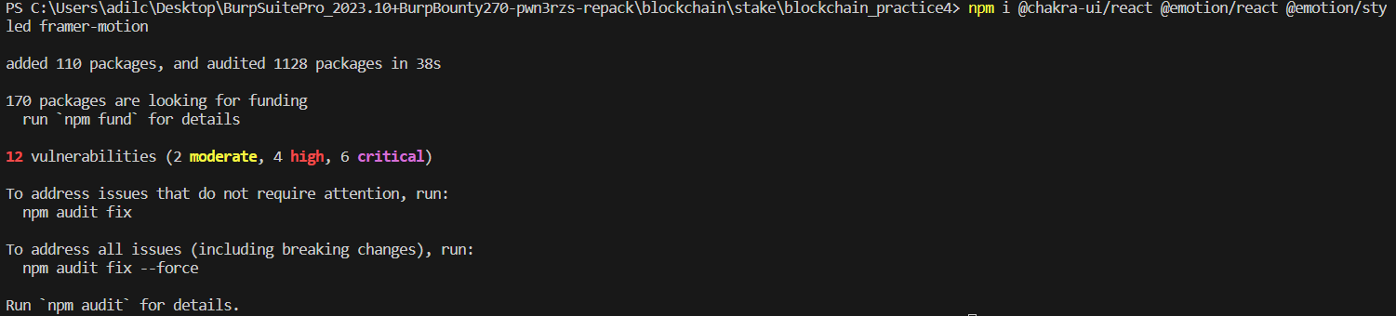

Connect my wallet to the ThirdWeb service

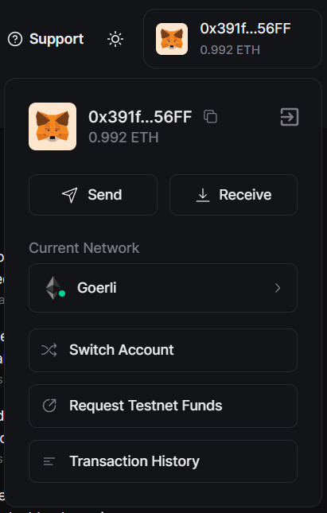

Set up regular token contract

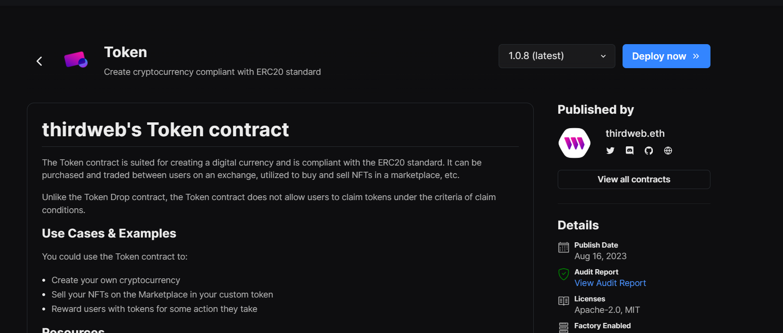

Deploy the StakeToken contract with listed parameters

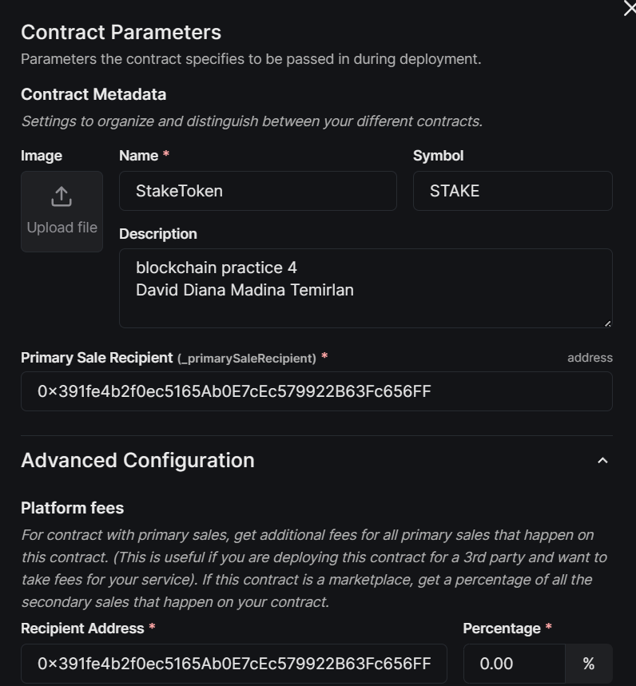

Paying gas for deployment of the contract

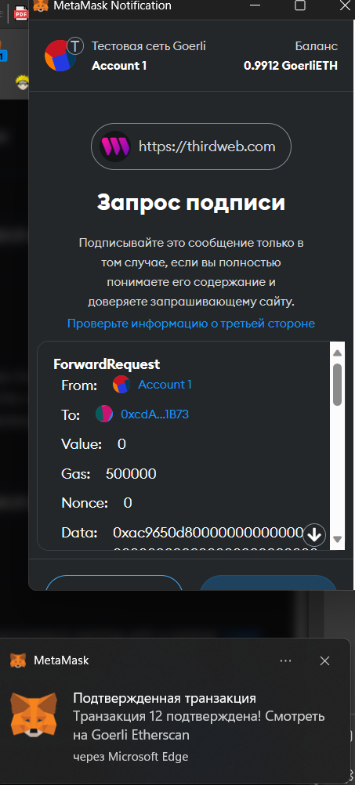

Our StakeToken now is created on the dashboard in the Goerli testnet

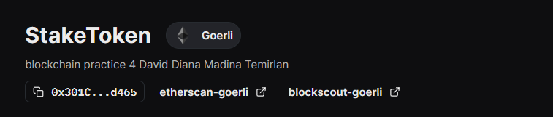

We have to mint tokens to out StakeToken

Now we must deploy token contract for the reward.

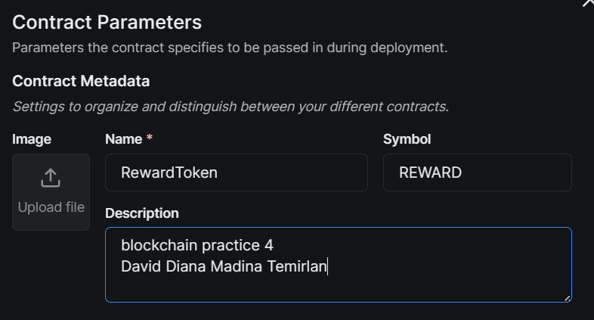

After covering the gas for deployment, we have to mint 1000000 RewardTokens

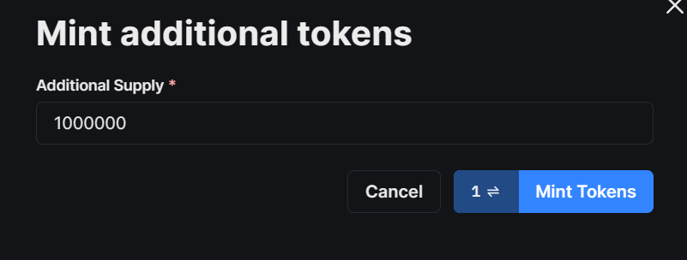

Deploying Stake on ERC20 token contract

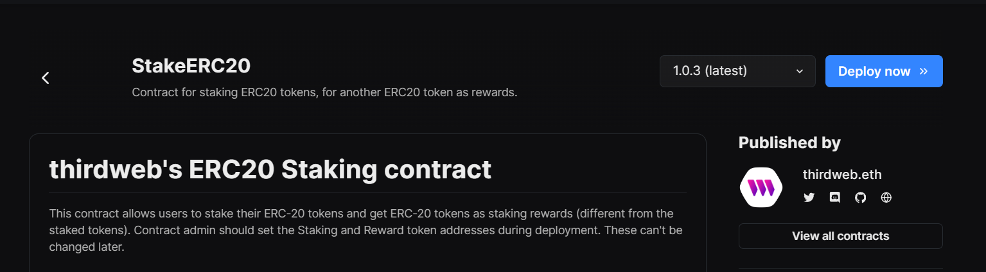

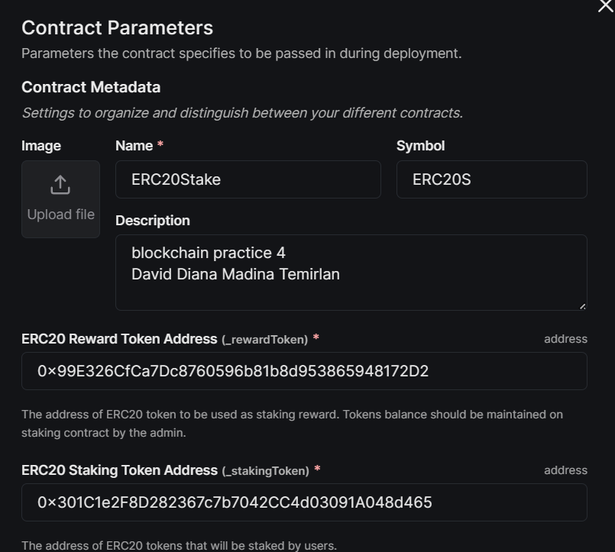

It requires Reward And Stake tokens addresses

0x99E326CfCa7Dc8760596b81b8d953865948172D2

0x301C1e2F8D282367c7b7042CC4d03091A048d465

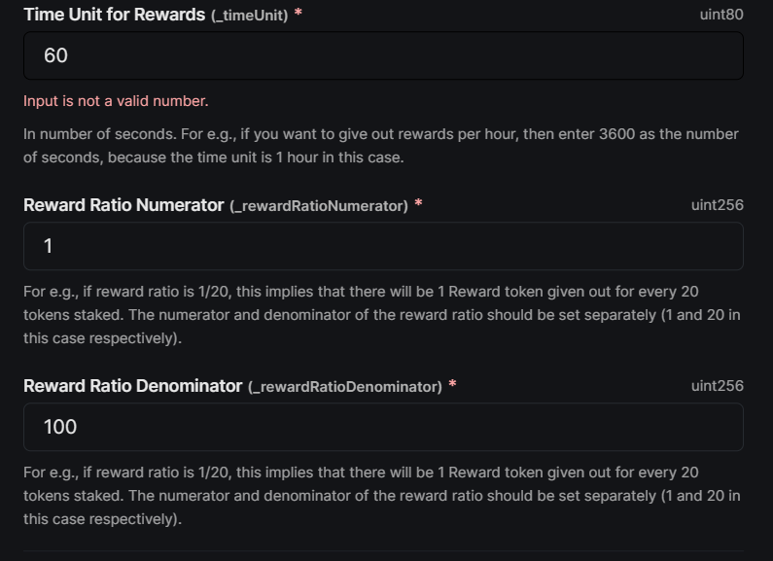

Time unit means in what period of time the reward will be sent

And reward ration means that for each 100 tokens staked user will get a 1 token as a reward

Before building the app itself we have to deposit some of the reward tokens to our ERC20Stake token for the approve

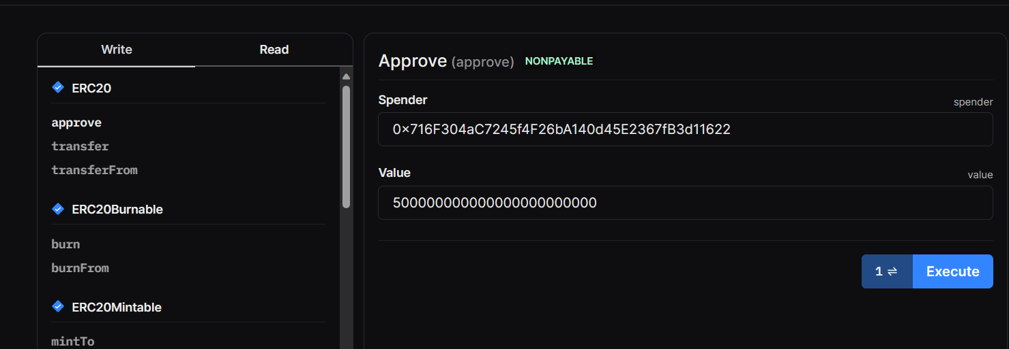

The Sender is our ERC20Stake address and the value should be in Wei so we using simple converter to ensure our value is right

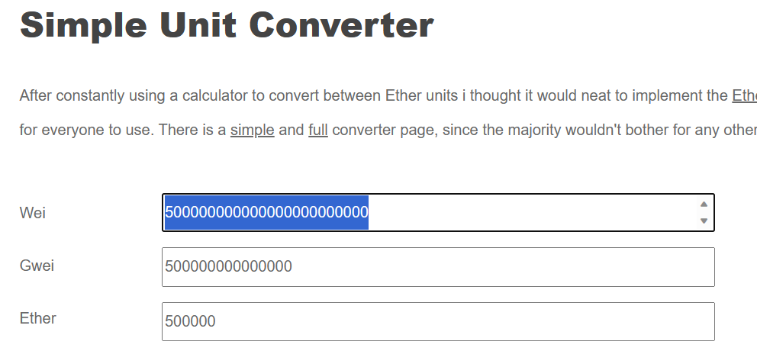

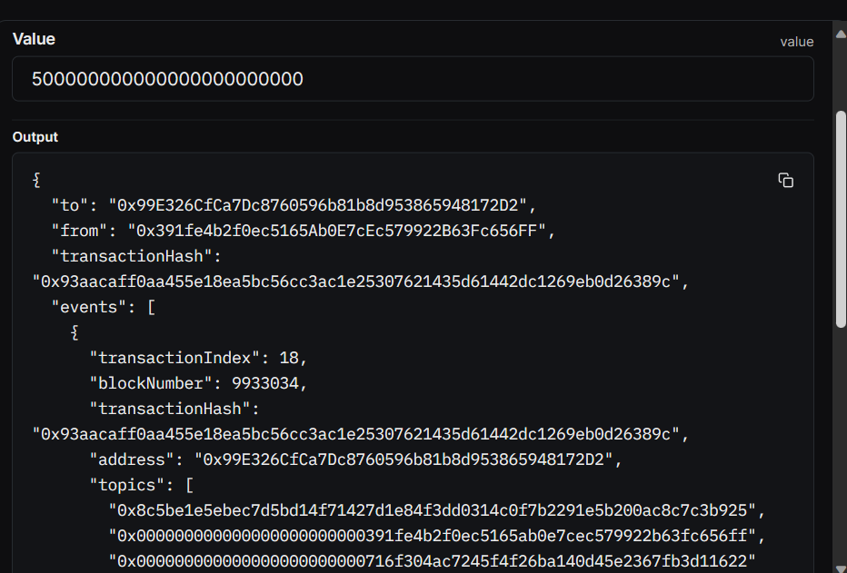

Now we have to deposit this 500000 tokens

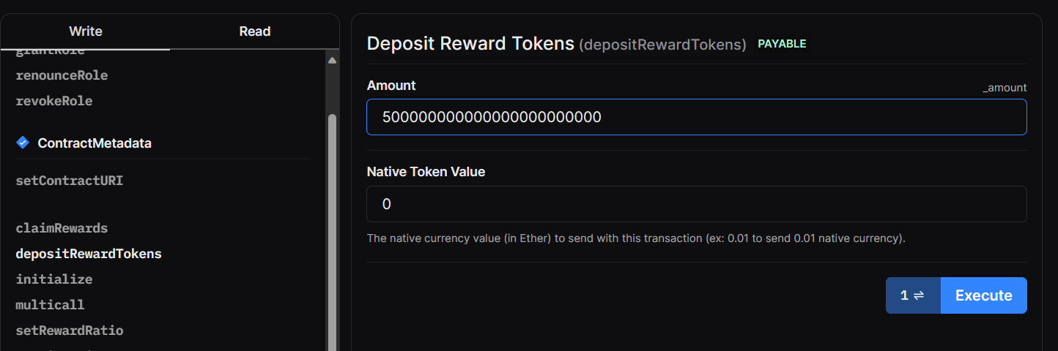

After this in out RewardToken dashboard we can see that we own only 500000 tokens after the deposit

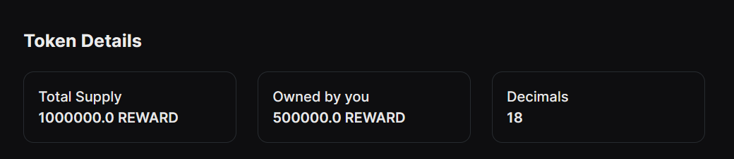

We finished deploying our contracts, now it is time to creating an dApp

With the help of NPX and thirdweb the base structure is already created

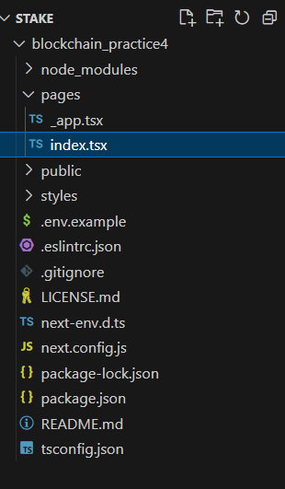

Specifying the goerli testnet and chakra-ui provider as a framework

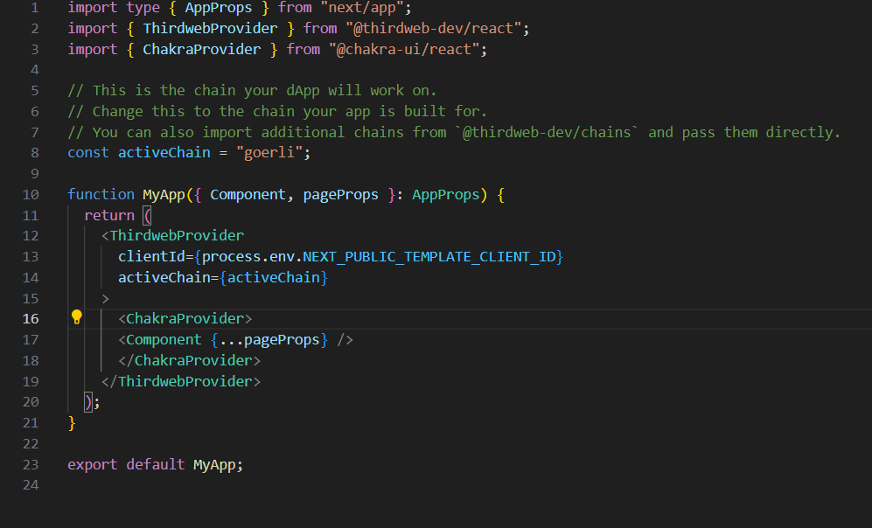

Specifying the constant addresses of our tokens and contract

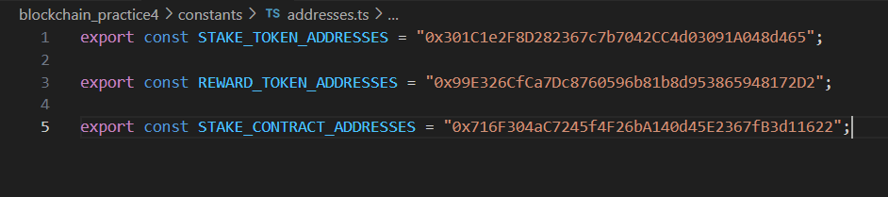

After editing some parts of the index page and running local host with the help of npm we can see that everything works fine

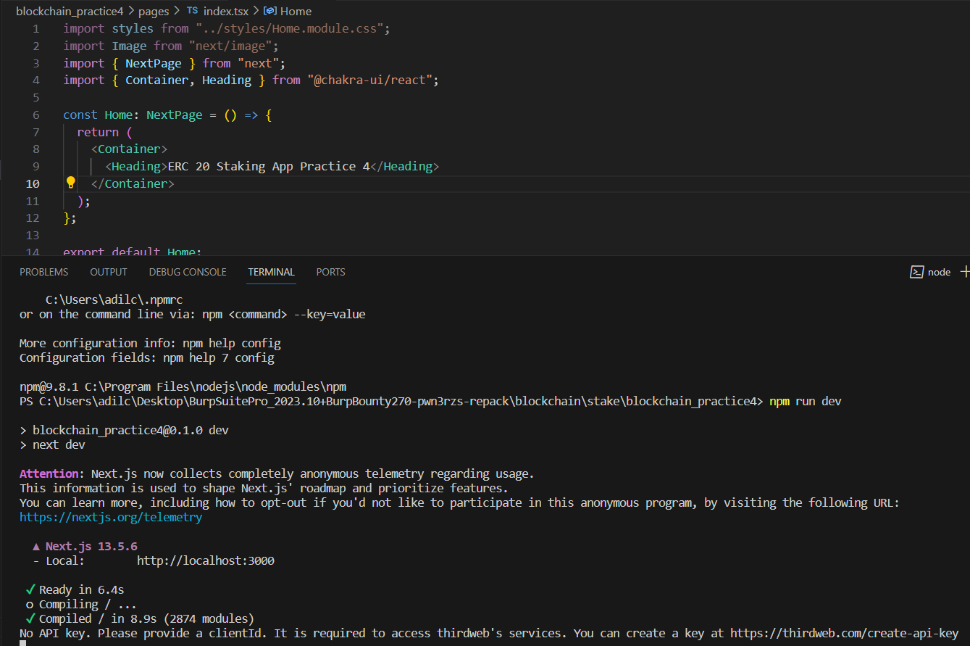

Write the navbar component using chakra-ui

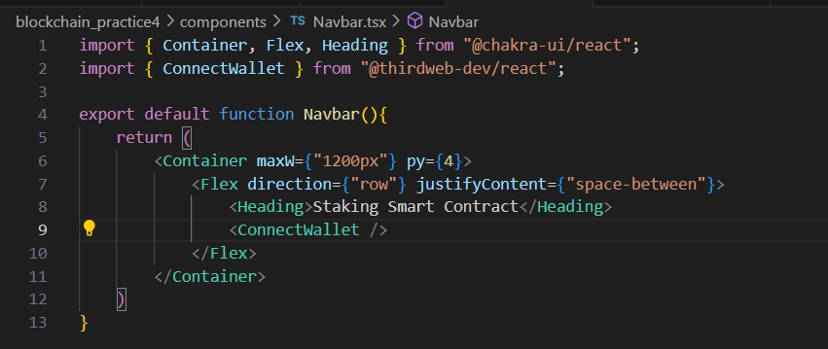

Now on localhost we have our navbar with the function of connecting of wallet

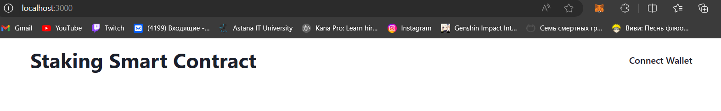

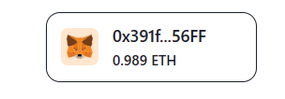

After construction the dApp works



